## Add AndroidManifest.xml into your Unity Project

1. Create a folder and name it as Plugins

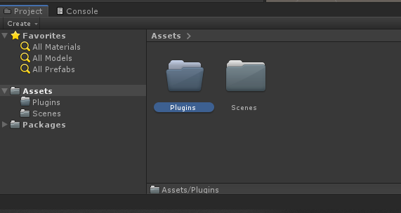

1. Create a folder inside the Plugins folder called Android

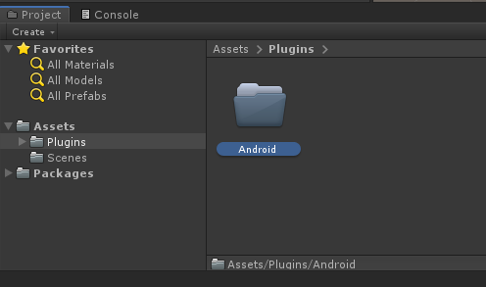

1. Copy your AndroidManifest file into this folder

This is where you can copy your xml file from

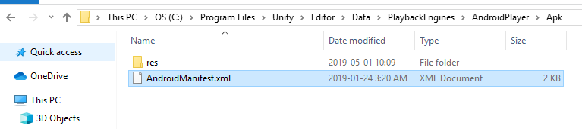

Then paste it into this folder

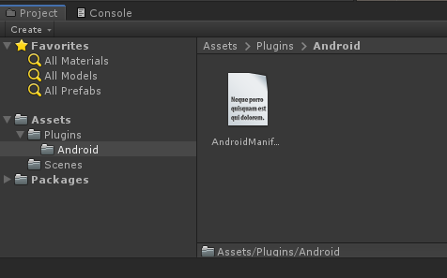

# Some common xml permissions

This is what a xml file looks like.

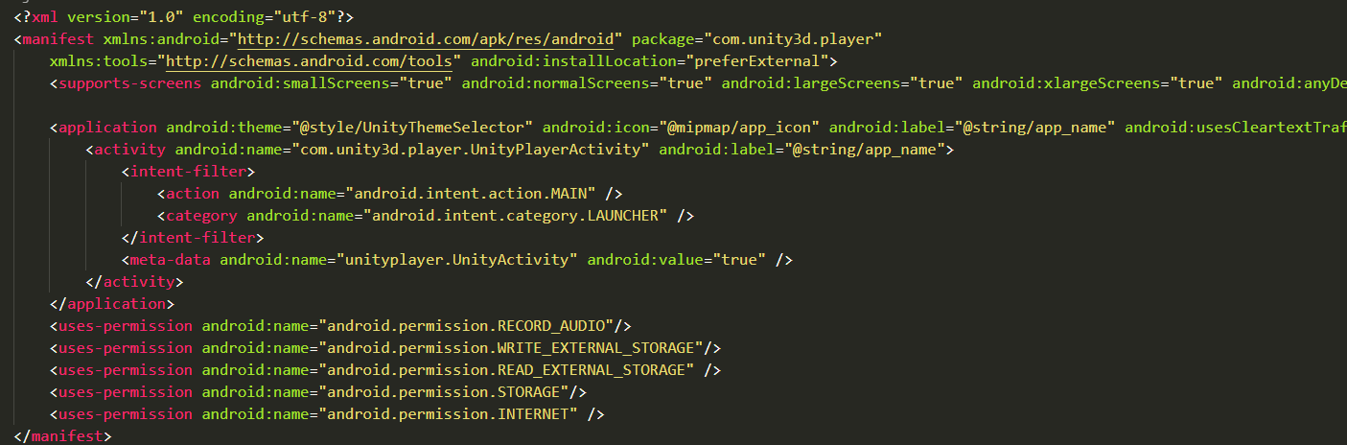

<uses-permission android:name="android.permission.RECORD_AUDIO"/>

//Allows app using microphone

<uses-permission android:name="android.permission.WRITE_EXTERNAL_STORAGE"/>

<uses-permission android:name="android.permission.READ_EXTERNAL_STORAGE" />

//Allows app write and read from storage

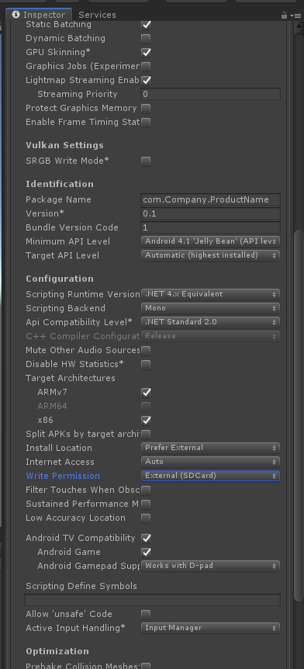File -> Build Settings -> Player Settings -> Android -> Other settings -> Write Permissioin

Change this to External(SDCard) no matter you have a SD card or not.